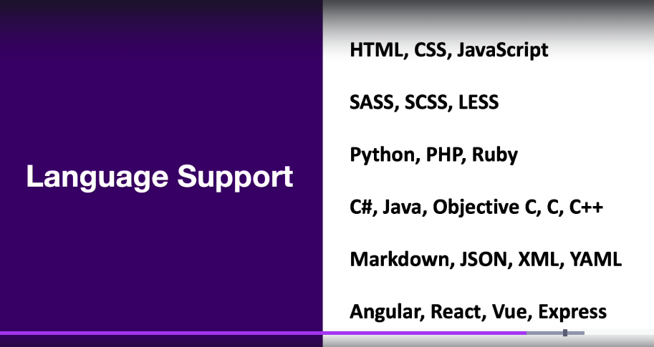

Learned also shortcut keys

Keyboard Shortcuts

Customize settings preferences

IntelliSense

Extensions